Assignment – 5
- Write a program using if–else to assign grades based on marks: >=90 → Grade A;>=75→ Grade B; >=50 → Grade C; <50 → Fail
Code:
<html>
<head>
<title>Q1</title>
<script>
let marks = 75;
if(marks >= 90) {
document.write("<h1>Your Garde is: O");
}
else if(marks >= 80) {
document.write("<h1>Your Garde is: E");
}
else if(marks >= 70) {
document.write("<h1>Your Garde is: A");
}
else if(marks >= 60) {
document.write("<h1>Your Garde is: B");
}
else if(marks >= 50) {
document.write("<h1>Your Garde is: C");
}
else if(marks >= 40) {
document.write("<h1>Your Garde is: D");
}
else {
document.write("<h1>Your Garde is: F");
}
</script>
</head>
<body bgcolor="cyan" text="red"> </body>
</html>
Output:

- Write a program using a for loop to calculate and print the factorial of a number.
Code:
<html>
<head>
<title>Factorial Calculation</title>
<script>
let n = 5;
let fact = 1;
for(let i = n; i > 0; i--) {
fact *= i;
}
document.write("<h1>The factorial of " + n + " is: " + fact + "</h1>");
</script>
</head>
<body bgcolor="cyan" text="red">
</body>
</html>
Output:
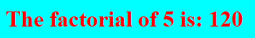
- Write a program using a while loop to reverse the digits of a number and check if the number is a palindrome or not.
Code:
<html>
<head>
<title>Palindrome Number</title>
<script>
function checkNumber() {
let num = 12321;
let originalNum = num;
let reversedNum = 0;
let remainder;
while (num > 0) {
remainder = num % 10;
reversedNum = (reversedNum * 10) + remainder;
num = Math.floor(num / 10);
}

if (originalNum === reversedNum) {
document.write("<h1>" + originalNum + " is a Palindrome Number! </h1>");
} else {
document.write("<h1>" + originalNum + " is NOT a Palindrome. </h1>");
}
}
window.onload = checkNumber;
</script>
</head>
<body bgcolor="cyan" text="red">
</body>
</html>
Output:
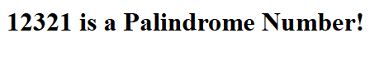
- Write a program to calculate and print the sum, average, largest, and smallest of elements of an array.
Code:
<html>
<head>
<title>Array Operations</title>
<script>
let x = [1, 2, 3, 4, 5];
let s = 0, a = 0, lr = x[0], sm = x[0];
for (let i = 0; i < x.length; i++) {
s += x[i];
if (x[i] > lr) {
lr = x[i];
}
if (x[i] < sm) {
sm = x[i];
}
}
document.write("<h1> Sum: ", s);
document.write("<br> Average: ", s / x.length);
document.write("<br>Largest: ", lr);
document.write("<br>Smallest: ", sm);
</script>
</head>
<body bgcolor="cyan" text="red">
</body>
</html>
Output:
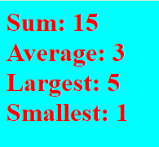
- Write a program to find the second largest element of an array without sorting it.
Code:
<html>
<head>
<title>Array Operations</title>
<script>
let x = [6, 2, 3, 4, 5];
let lr = -Infinity;
let slr = -Infinity;
for (let i = 0; i < x.length; i++) {
if (x[i] > lr) {
slr = lr;
lr = x[i];
} else if (x[i] > slr && x[i] < lr) {
slr = x[i];
}
}
document.write("<h1>Largest: ", lr);
document.write("<br>Second Largest: ", slr);
</script>
</head>
<body bgcolor="cyan" text="red">
</body>
</html>
Output:
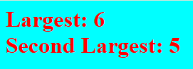
- Write a program to remove duplicate elements from an array and print the new array.
Code:
<html>
<head>
<title>Remove Duplicate Elements</title>
<script>
let x = [6, 2, 5, 4, 5, 2, 6];
let y = Array.from(new Set(x));
document.write("<h2>The Original Array is: ",x);
document.write("<br>After Removing the Duplicate Values : " + y);
</script>
</head>
<body bgcolor="cyan" text="red">
</body>
</html>
Output:
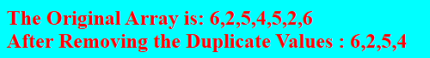
- Write a program to count how many times each element occurs in an array.
Code:
<html>
<head>
<title>Frequency of Elements</title>
<script>
let x = [6, 2, 5, 4, 5, 2, 6];
document.write("<h2>The Original Array is: " + x + "<br>");
let y = Array.from(new Set(x));
for (let i = 0; i < y.length; i++) {
let count = 0;
for (let j = 0; j < x.length; j++) {
if (x[j] === y[i]) {
count++;
}
}
document.write("Element " + y[i] + " appears " + count + " times.<br>");
}
</script>
</head>
<body bgcolor="cyan" text="red">
</body>
</html>
Output:
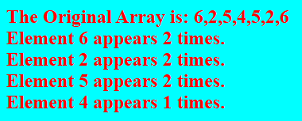
- Write a function isPrime(num) that returns true if the number is prime, otherwise false. Test with different numbers.
Code:
<html>
<head>
<title>Prime</title>
<script>
function isprime(n) {
for(let i = 2; i<n ; i++) {
if(n % i === 0) {
return false;
}
}
return true;
}
document.write("<h1>",isprime(2));
</script>
</head>
<body bgcolor="cyan" text="red">
</body>
</html>
Output:
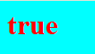
- Write a function to check whether a number is an Armstrong number (e.g., 153 → Armstrong, 123 → not Armstrong).
Code:
<html>
<head>
<title>Armstrong</title>
<script>
function isArmstrong(n) {
let x = n, s = 0;
while (x > 0) {
let a = x % 10;
s += a * a * a;
x = Math.floor(x / 10);
}
return s == n;
}
let x = 153;
if(isArmstrong(x)) {
document.write("<h1>" + x + " is a Armstrong Number.");
}
else {
document.write("<h1>" + x + " is Not a Armstrong Number.");
}
</script>
</head>
<body bgcolor="cyan" text="red">
</body>
</html>
Output:
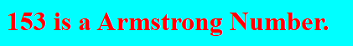
- Write a function that takes an array of numbers and returns two new arrays: one containing even numbers and one containing odd numbers.
Code:
<html>
<head>
<title>Separate Number</title>
<script>
function separateNumbers(arr) {
let x = new Set(arr);
let evens = [];
let odds = [];
for (let num of x) {
if (num % 2 === 0) {
evens.push(num);
} else {
odds.push(num);
}
}
return [evens, odds];
}
let arr = [20, 10, 15, 15, 20, 25, 45, 33, 20];
const [even, odd] = separateNumbers(arr);
document.write("<h3> The Original Array is: " + arr);
document.write("<h3> Even Numbers Are: " + even);
document.write("<br> Odd Numbers Are: " + odd);
</script>
</head>
<body bgcolor="cyan" text="red">
</body>
</html>
Output:
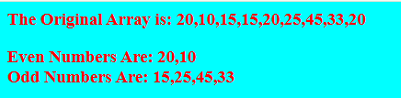
- Write a function reverseArray(arr) that reverses the elements of an array without using the built- in reverse() method.
Code:
<html>
<head>
<title>Reverse</title>
<script>
function reverseArray(x) {
let rev = [];
for (let i = x.length - 1; i >= 0; i--) {
rev.push(x[i]);
}
return rev;
}
let x = [1, 21, 13, 4, 6];
document.write("<h1>The Original Array is: " + x + "</h1>");
document.write("<h1>The Reversed Array is: " + reverseArray(x) + "</h1>");
</script>
</head>
<body bgcolor="cyan" text="red">
</body>
</html>
Output:
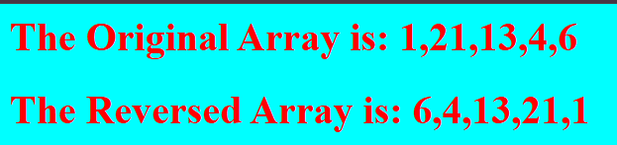
- Write a function generateFibonacci(n) that generates the first n Fibonacci numbers and returns them in an array.
Code:
<html>
<head>
<title>Fibonacci</title>
<script>
function Fibonacci(n) {
let a = 0, b = 1;
let fib = [];
for (let i = 0; i < n; i++) {
fib.push(a);
let next = a + b;
a = b;
b = next;
}
return fib;
}
let result = Fibonacci(10);
document.write("<h1>Fibonacci Series: " + result + "</h1>");
</script>
</head>
<body bgcolor="cyan" text="red">
</body>
</html>
Output:
